Kilmagner National School

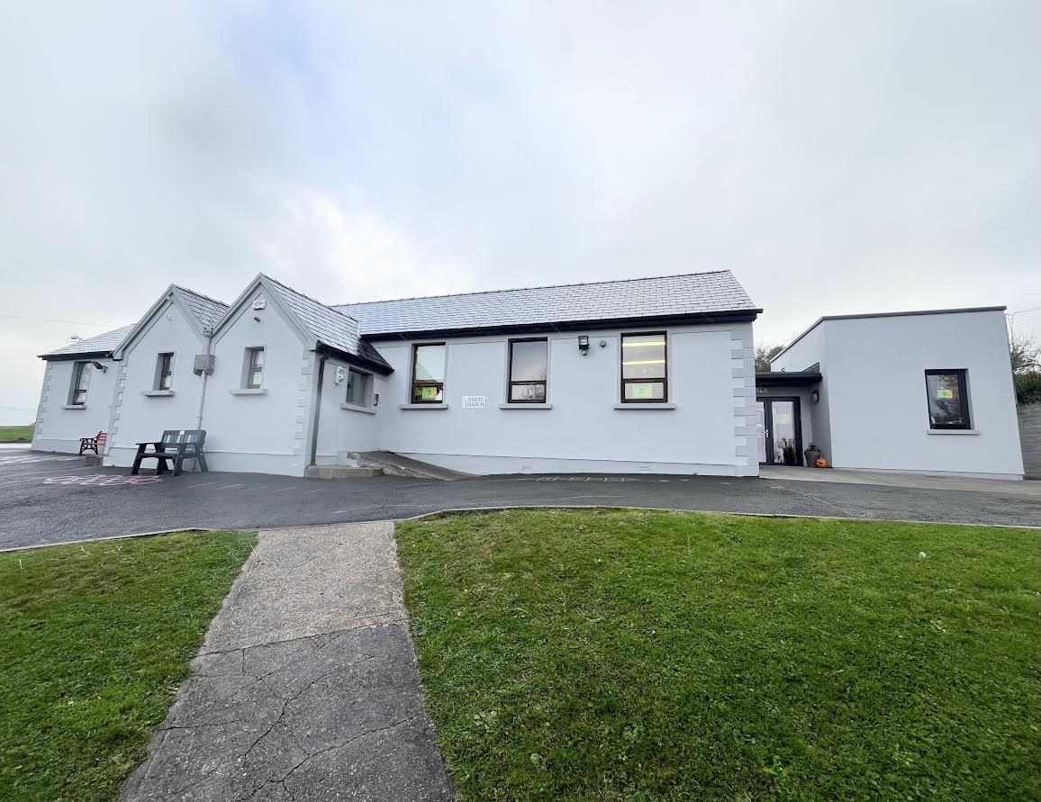 Kilmagner, Fermoy, Co. Cork P61V968
Phone: (025) 36802 Roll Number: 11337W Email: office@kilmagnerns.ie
Website: www.kilmagnerns.ie

Child Safeguarding Statement and Risk Assessment

Child Safeguarding Statement
Our School is a primary school providing primary education to pupils from Junior Infants to Sixth Class.
In accordance with the requirements of the Children First Act 2015, Children First: National Guidance for the Protection and Welfare of Children 2017, the Addendum to Children First (2019), the Child Protection Procedures for Primary and Post Primary Schools (revised 2023) and Tusla Guidance on the preparation of Child Safeguarding Statements, the Board of Management of this school has agreed the Child Safeguarding Statement set out in this document.

- The Board of Management has adopted and will implement fully and without modification the Department’s Child Protection Procedures for Primary and Post Primary Schools (revised (2023) as part of this overall Child Safeguarding Statement

- The Designated Liaison Person (DLP) is: Stephen Bennett

- The Deputy Designated Liaison Person (Deputy DLP) is Sarah O’Farrell

- The Relevant Person is Stephen Bennett

- The Board of Management recognises that child protection and welfare considerations permeate all aspects of school life and must be reflected in all of the school’s policies, procedures, practices and activities. In its policies, procedures, practices and activities, the school will adhere to the following principles of best practice in child protection and welfare:

The school will:
- recognise that the protection and welfare of children is of paramount importance, regardless of all other considerations;
- fully comply with its statutory obligations under the Children First Act 2015 and other relevant legislation relating to the protection and welfare of children;
- fully co-operate with the relevant statutory authorities in relation to child protection and welfare matters;
- adopt safe practices to minimise the possibility of harm or accidents happening to children and protect workers from the necessity to take unnecessary risks that may leave themselves open to accusations of abuse or neglect;
- develop a practice of openness with parents and encourage parental involvement in the education of their children; and
- fully respect confidentiality requirements in dealing with child protection matters.

The school will also adhere to the above principles in relation to any adult pupil with a special vulnerability.

- The following procedures/measures are in place:

- In relation to any member of staff who is the subject of any investigation (howsoever described) in respect of any act, omission or circumstance in respect of a child attending the school, the school adheres to the relevant procedures set out in Chapter 7 of the Child Protection Procedures for Primary and Post Primary Schools (revised 2023) and to the relevant agreed disciplinary procedures for school staff which are published on the gov.ie website.
- In relation to the selection or recruitment of staff and their suitability to work with children, the school adheres to the statutory vetting requirements of the National Vetting Bureau (Children and Vulnerable Persons) Acts 2012 to 2016 and to the wider duty of care guidance set out in relevant Garda vetting and recruitment circulars published by the Department of Education and available on the gov.ie website.
- In relation to the provision of information and, where necessary, instruction and training, to staff in respect of the identification of the occurrence of harm (as defined in the 2015 Act) the school:
    - Has provided each member of staff with a copy of the school’s Child Safeguarding Statement
    - Ensures all new staff are provided with a copy of the school’s Child Safeguarding Statement
    - Encourages staff to avail of relevant training
    - Encourages Board of Management members to avail of relevant training
    - The Board of Management maintains records of all staff and Board member training

- In relation to reporting of child protection concerns to Tusla, all school personnel are required to adhere to the procedures set out in the Child Protection Procedures for Primary and Post Primary Schools (revised 2023), including in the case of registered teachers, those in relation to mandated reporting under the Children First Act 2015.
- All registered teachers employed by the school are mandated persons under the Children First Act 2015
- In accordance with the Children First Act 2015 and the Addendum to Children First (2019), the Board has carried out an assessment of any potential for harm to a child while attending the school or participating in school activities. A written assessment setting out the areas of risk identified and the school’s procedures for managing those risks is included with the Child Safeguarding Statement.
- The various procedures referred to in this Statement can be accessed via the school’s website, the gov.ie website or will be made available on request by the school.

- This statement has been published on the school’s website and has been provided to all members of school personnel, the Parents’ Association and the patron. It is readily accessible to parents and guardians on request. A copy of this Statement will be made available to Tusla and the Department if requested.

- This Child Safeguarding Statement will be reviewed annually or as soon as practicable after there has been a material change in any matter to which this statement refers.

This Child Safeguarding Statement was adopted by the Board of Management on November 2025
This Child Safeguarding Statement was reviewed by the Board of Management on November 2025

Signed: 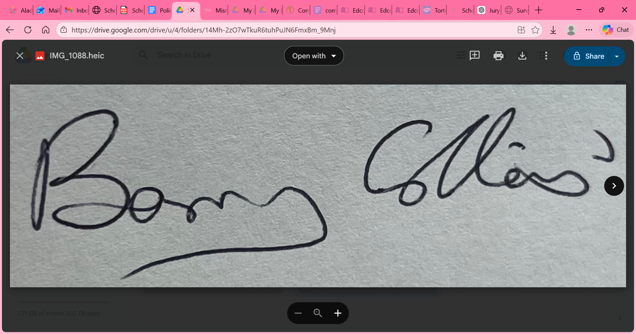 Date: 27-11-2025
Chairperson Board of Management

Signed:  Date: 27-11-2025
School Principal

Child Safeguarding Risk Assessment

Written Assessment of Risk in this school

In accordance with section11 of the Children First Act 2015 and with the requirement of Chapter 8 of the Child Protection Procedures for Primary and Post-Primary Schools (revised 2023), the following is the Written Risk Assessment of this school.

- List of School Activities | - The School has identified the following risk of harm in respect of its activities - | - The School has the following procedures in place to address risk identified in this assessment -
School Staff
Training of school personnel in Child Protection matters | Harm not recognised or reported promptly | Child Safeguarding Statement & DES procedures made available to all staff  DLP& DDLP to attend OIDE face to face training  All Staff to view Túsla training module & any other online training offered by OIDE  BOM records all records of staff and board training
Classroom teaching | Harm by school personnel | Child Safeguarding Statement  All teachers Garda Vetted  Teachers are advised not to speak to a pupil alone
One to one teaching | Harm by school personnel | Table between teacher and pupil  Glass in door and or window through which teacher and pupils are visible  Another member of staff knows where the pupil is at all times
Substitute/Temporary Teachers covering for teachers on sick leave, maternity leave, parental leave or other type of leave | Harm to pupils | Child Safeguarding Statement made available to the substitute teacher  All substitute teachers are Garda Vetted and have a statutory declaration. References are checked if appropriate.  Substitute teachers are advised not to speak to a pupil alone
Pupils in the office with an adult | Harm to pupils | Desk between adult and pupil  Glass in window and door through which adult and pupil are visible
Transitions year and IT Students participating in work experience in school | Harm to pupils | Child Safeguarding Statement  All students over 16 years are Garda Vetted by their organisation and there is a joint vetting agreement in place between the organisation and the school.
Student teachers participating in teaching practice in school | Harm to pupils | Child Safeguarding Statement  All students are Garda Vetted by their organisation and there is a joint vetting agreement in place between the organisation and the school  Class Teacher remains with the student teacher at all times
Educational Psychologist assessing a pupil | Harm to pupils | Garda vetted by NEPS  Table between psychologist and pupil  Glass in door and window through which psychologist and pupil are visible
School Photographer | Harm to pupils | Garda vetted by diocese for school  Glass in windows and door through which photographer and pupils can be seen
Sport coaches coming in | Harm to pupils | Child Safeguarding Statement  All coaches are Garda Vetted by their organisation and there is a joint vetting agreement in place between the organisation and the school  Class Teacher remains with the sports coach at all times
Use of external personnel to supplement the curriculum e.g. drumming teacher, dancing teacher, Zumba teacher, | Harm to pupils | Child Safeguarding Statement  All personnel are Garda Vetted  Class Teacher remains with the person at all times
Care of Children with special needs, including intimate care needs | Harm by school personnel | Regular review of pupil needs  Pupil personal plans for pupils with intimate care needs  Advice sought from special needs support service
Curricular Provision in respect of SPHE, RSE, Stay safe. | Non-teaching of same | School implements SPHE, RSE, Stay Safe in full  All teachers are reminded when Stay Safe is to be taught – 2nd term each year.
Pupils outside of the Classroom
Daily arrival and dismissal of pupils | Harm from older pupils, adults in the playground | Arrival supervised by a teacher. SNAs on the yard as well.  Parents are asked to drop their children to the yard where pupils are supervised by a teacher from 08.45am. Teacher rota in place. All teachers furnished a copy of the rota.
Sos and lunch times | Adults entering the playground, harm by other pupils | Supervision at all break times by 1 teacher on the yard.  Yard rules
Toilet areas | Inappropriate behaviour, adult entering the toilet | The atmosphere of reporting inappropriateness is encouraged.  Toilets are in all classrooms.  There are specific toilets assigned to staff and visiting adults.
Pupils walking around the school on messages/with medals/going to the office when sick | Harm to pupil by unknown adult | The front door is accessed by code or buzzer.  Pupils are always in twos.
School Tours | Harm to pupil  Venues /destinations are checked for appropriateness | Two teachers travel accompanied by SNA where applicable with each class on school tour.  Only parents who are Garda vetted for this school are allowed to accompany classes on tour.
Practices in the Church for Confession, Confirmation & First Communion day & Holy day masses | Harm to pupils | Two teachers and a SNA where applicable travel to the church with the class. The class is supervised at all times.  Choir supervised by a teacher.
Management of Pupils in School
LGBT Children/Pupils perceived to be LGBT | Bullying | Bí Cineálta Policy  Code of Behaviour
Managing of challenging behaviour amongst pupils | Injury to pupils and staff | Health & Safety Policy  Code Of Behaviour  Anti Bullying Policy  NEPS and other outside agencies behavioural intervention recommendations.  Working with parents and all stakeholders.
Administration of Medicine  Administration of First Aid | Harm to pupil | Health & Safety Policy
Prevention and dealing with bullying  amongst pupils. | Harm to pupil | Bí Cineálta Policy  Code of Behaviour  Anti Bullying Week
Use of technology for online teaching and remote learning, e.g. Zoom | Bullying,  Harm to pupil | Code of Behaviour  Bí Cinnealta Policy
Use of video/photography/other media to record school events | Bullying, harm to pupils | Data protection policy  Permission from parents to take and use photographs of their child on POD enrolment form  Class teachers only to take photos- delete once uploaded to Google drive

Important Note: It should be noted that risk in the context of this risk assessment is the risk of “harm” as defined in the Children First Act 2015 and not general health and safety risk. The definition of harm is set out in Chapter 4 of the Child Protection Procedures for Primary and Post-Primary

Signed: Date: 27-11-2025
Chairperson Board of Management

Signed: Date: 27-11-2025

School Principal

