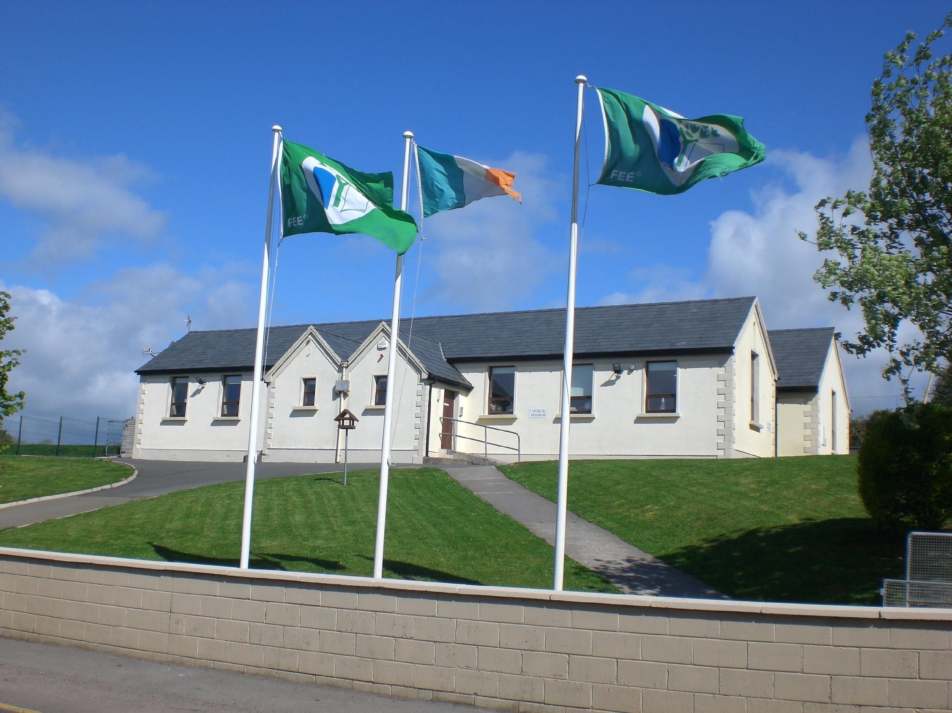
Kilmagner National School

Fermoy, Co. Cork Established 1878

Phone: (025) 36802 e-mail address: office@kilmagnerns.ie

Code of Behaviour
In devising the Code, consideration has been given to the particular needs and circumstances of this School. The aim is to ensure that the individuality of each child is accommodated while acknowledging the right of each child to an education in a relatively disruptive free environment.
Every effort will be made by all members of staff to adopt a positive approach to the question of behaviour in the School.
It is agreed that a high standard of behaviour requires a strong sense of Community within the school and a high level of co-operation among staff and between staff, pupils and parents.
The rules are being kept to a minimum and are positively stated in terms of what pupils should do.
The overall responsibility for discipline within the school rests with the Principal. Each teacher has responsibility for the maintenance of discipline within his/her own classroom, while sharing a common responsibility for good order within the School premises and in the school yard.
SCHOOL RULES
We expect children to conform to general standards of behaviour and work, and we look for the support of parents in attaining these standards. Our school rules are simple and are designed largely to protect persons and property.

Please Note:
- Homework should be checked regularly by parents. Please check the homework journal to see if there is a note in it. If you have a concern about the same, please make an appointment to meet the teacher.
- Always be on time for school.
- School begins at 9.00 a.m. and finishes at 2.40 p.m. each day. Both Infant Classes finish at 1.40p.m.
- Students remain on School property at all times during the day.
- A Sign in/Sign Out Book is used to record details of any child leaving the school during the school day. It must be signed by the parent / guardian collecting and delivering back the child. Please ask the Class Teacher for the same.
- Pupils are expected to bring a sensible, nutritious lunch to school as outlined in the school’s Healthy Eating policy.
- Wearing a school Uniform is obligatory. The uniform comprises a school crested Kilmagner N.S. blue half-zip, navy tracksuit pants / shorts and the Kilmagner N.S. jersey / white polo shirt.
- All clothing should be marked clearly with the child’s full name on the label.
- For safety reasons, hanging/dangling earrings are ruled out. Make-up / tan is also not permitted.
- No dramatic change of hair colour is allowed
A note on Aladdin is required:
- For permission to leave the School during school hours e.g. dental appointment. (Please let us know if someone different is collecting your child).
- When homework is not done.
- To explain absenteeism
- If a pupil is not participating in Swimming or P.E.
- We wish to remind parents of the school’s obligation under the Education Welfare Act 1998 to report to the National Education Welfare Board (N.E.W.B.) any child’s absence from school greater than 20 days (for whatever reason) over the course of the school year. It is absolutely necessary that a note signed and dated, and giving the reasons for absence is forwarded to your child’s teacher in the event that your child is absent from school. We would encourage all children to avoid being absent unless it’s absolutely necessary. Remember every day counts!
- Mobile phones/electronic games are not allowed in the school under any circumstances.
- Never run in the classrooms or in the corridor.
- When the bell rings in the yard, walk to the line and wait quietly for the teacher on duty.
- Never run in the carpark, use the footpaths where possible and always watch for moving vehicles. Remember Safety First!
- Respect everyone in the school; Respect school property and help to keep the school and the schoolgrounds litter –free; Treat your schoolbooks with respect. If they are rented under the Schoolbook rental scheme don’t write on them.
- Pupils are required to show respect for themselves, their fellow pupils and their teachers. Bullying and abusive behaviour is unacceptable and will not be tolerated.(See Bí Cineálta Policy)
Procedures for Noting and Reporting an Incident of Bullying Behaviour
- Teachers will take a calm, unemotional, problem solving approach when dealing with incidents of bullying behaviour, reported by either pupils, staff or parents/guardians.
- Such incidents will be investigated outside the classroom situation to avoid the public humiliation of the victim or the pupil engaged in bullying behaviour.
- In any incident of bullying, the teacher will speak separately to the pupils involved in an attempt to get both sides of the story.
- All interviews will be conducted with sensitivity and with due regard to the rights of all pupils concerned. Pupils who are not directly involved can also provide useful information in this way.
- If a group is involved, each member will be interviewed individually and then the group will be met as a group.
- If it is concluded that a pupil has been engaged in bullying behaviour, it will be made clear to him/her how he/she is in breach of the Code of Behaviour and Discipline / Bí Cineálta and efforts to get him/her to see the situation from the victim’s point of view will be made.
- Teachers who are investigating cases of bullying behaviour will keep a written record of their discussions with those involved.
- In cases where it has been determined that bullying behaviour has occurred, the class teacher will meet with the parents of the two parties involved and follow the Bí Cineálta Policy. If these are once off incidents, the Code of Behaviour will be followed.
- The actions taken will be explained as will the reasons for taking those actions. Ways in which they can reinforce or support the actions taken by the school will be discussed.
- A follow-up meeting with the two parties involved will be arranged.
- This Code of Discipline is balanced and fair. It is hoped that it will promote positive patterns of behaviour and good relationships.
SANCTIONS
Despite the best efforts of School Staff, Parents and Students, it is inevitable that behavioural problems will occur.
The following strategies may be used, at the school’s discretion, to show disapproval of unacceptable behaviour:
- Reasoning with the pupil
- Reprimand (including advice on how to improve)
- Temporary separation from peers, friends or others.
- Loss of privileges
- Detention during a break
- Prescribing additional work
- Referral to the Principal
- Communication with Parents
- Suspension
Procedure to be followed before suspension is imposed:
For Gross misbehaviour or repeated instances of serious misbehaviour, suspension will be considered.
Where there are instances of this kind, the Chairperson of the Board of Management will be informed and the parents will be requested in writing to attend at the School to meet the Chairperson and the Principal.
If the parents do not give an undertaking that the pupil will behave in an acceptable manner in the future, the pupil may have to be suspended for a temporary period.
In the case of gross misbehaviour, the Board shall authorise the Chairperson or Principal to sanction an immediate suspension pending a discussion of the matter with the parents.
Note: Where misbehaviour persists, it is important to try to find the underlying causes and to discuss the matter with the parents. Every effort will be made to ensure that parents are kept well informed.
See Kilmagner N.S.’s Bí Cineálta Policy (Ratified by B.O.M. on 12/06/2025) for the most up to date information.
Notes on Suspension
Appendix A to Circular 7/88 Rule 130 (5) “Rules for National School” states that:
“When the Board of Management deems it necessary to make provision in the Code of
Discipline to deal with continuous disruptive pupils or with a serious breach of
Discipline, by authorizing the Chairperson or Principal to exclude a pupil or pupils from
the school, the maximum initial period of such exclusion shall be three days.
A special decision of the Board of Management is necessary to authorise a further period
of exclusion up to a maximum of 10 school days to allow for consultation with the pupils’
Parents or Guardians. In exceptional circumstances, the Board of Management may
authorise a further period of exclusion in order to enable the matter to be reviewed.”

“In the case of a single incident of gross misbehaviour, or repeated instances of serious
misbehaviour, the Board of Management shall authorize the Chairperson or Principal to sanction an immediate suspension, pending a discussion of the matter with the parents.

Signed: 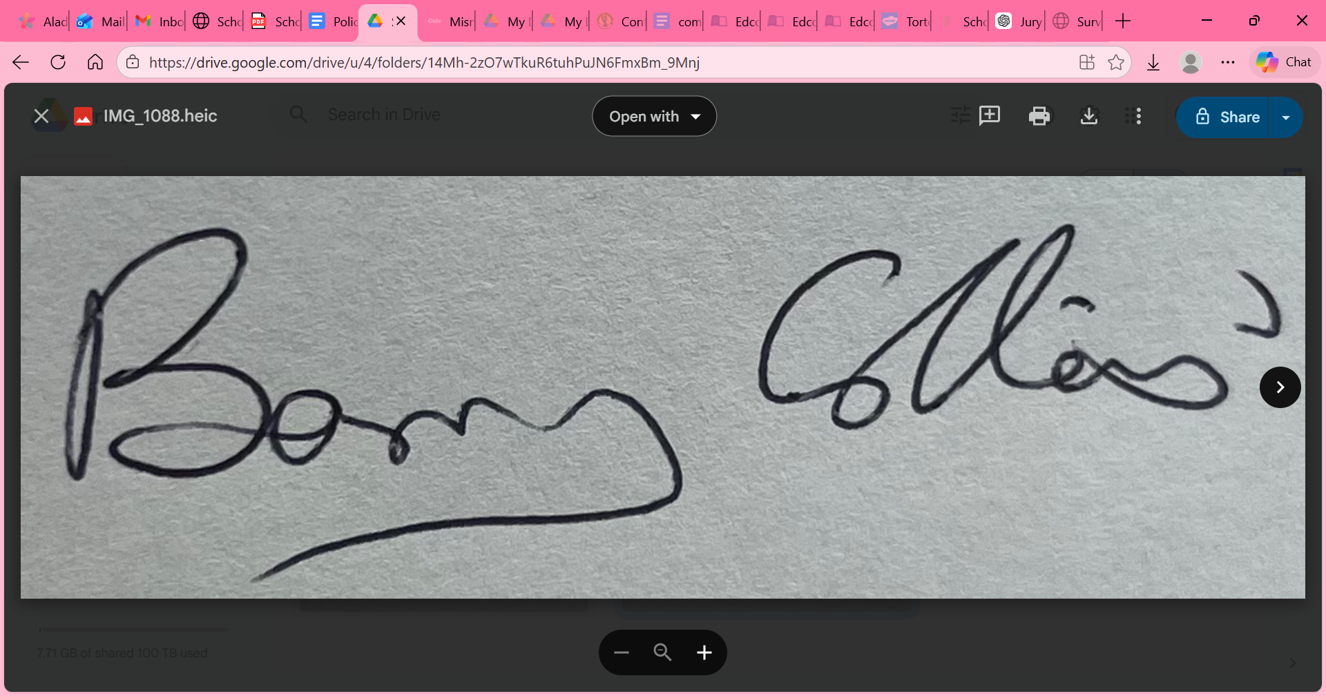 Date: 22-10-2025
Chairperson Board of Management
Signed: 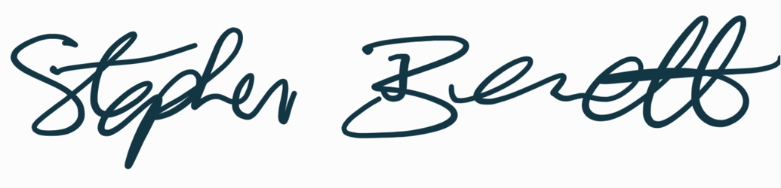 Date: 22-10-2025
School Principal

