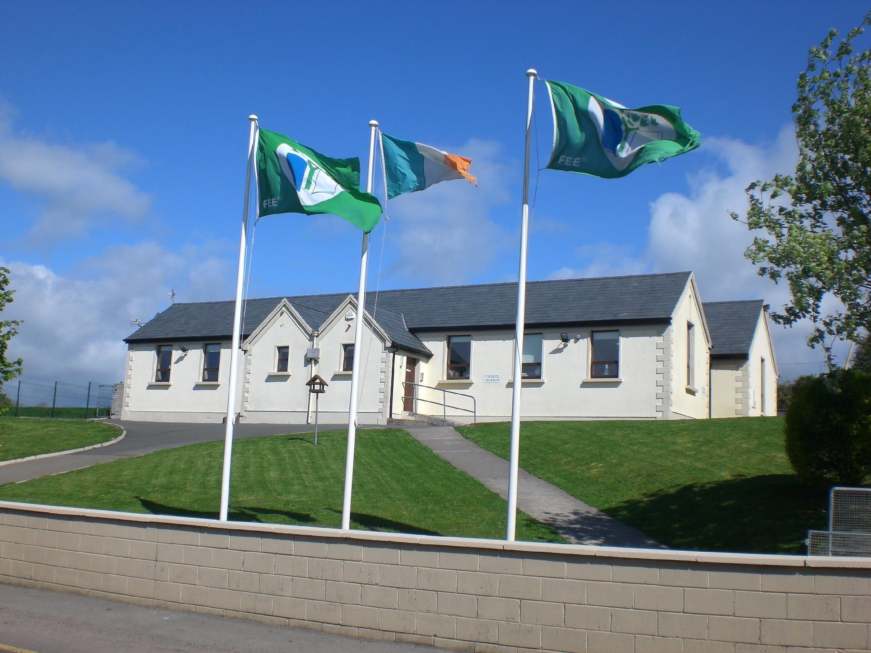

Kilmagner National School

Fermoy, Co. Cork Established 1878

Phone: (025) 36802 e-mail address: office@kilmagnerns.ie

Bí Cineálta Policy

to Prevent and Address Bullying Behaviour.

The Board of Management of Kilmagner N.S. has adopted the following policy to prevent and address bullying behaviour.
This policy fully complies with the requirements of Bí Cineálta: Procedures to Prevent and Address Bullying Behaviour for Primary and Post-Primary Schools 2024.
The board of management acknowledges that bullying behaviour interferes with the rights of the child as set out in the United Nations Convention on the Rights of the Child. We all, as a school community, have a responsibility to work together to prevent and address bullying behaviour and to deal with the negative impact of bullying behaviour.
We are committed to ensuring that all students who attend our school are kept safe from harm and that the wellbeing of our students is at the forefront of everything that we do. We recognise the negative impact that bullying behaviour can have on the lives of our students and we are fully committed to preventing and addressing bullying behaviour.
We confirm that we will, in accordance with our obligations under equality legislation, take all such steps that are reasonably practicable to prevent the harassment of students or staff on any of the nine grounds specified: gender, civil status, family status, sexual orientation, religion, age, disability, race and membership of the Traveller community.

Definition of bullying
Bullying is defined in Cineáltas: Action Plan on Bullying and Bí Cineálta: Procedures to Prevent and Address Bullying Behaviour for Primary and Post-Primary Schools as targeted behaviour, online or offline that causes harm. The harm caused can be physical, social and/or emotional in nature. Bullying behaviour is repeated over time and involves an imbalance of power in relationships between two people or groups of people in society. The detailed definition is provided in Chapter 2 of the Bí Cineálta procedures.
Each school is required to develop and implement a Bí Cineálta policy that sets out how the school community prevents and addresses bullying behaviour. Strategies to deal with inappropriate behaviour that is not bullying behaviour are provided for within the school’s Code of Behaviour.

Section A: Development/review of our Bí Cineálta policy to prevent and address bullying behaviour
All members of our school community were provided with the opportunity to input into the development/review of this policy.

 | Date consulted | Method of consultation
School Staff | 14/03/2025 | Whole-Staff Meeting / Groupwork
Students | 08/05/2025 | Discussions led by class teachers, focus groups facilitated by 6th class pupils.
Parents | 09/05/2025 | Google Forms Document
Board of Management | 29/05/2025 | Meeting
Date policy was approved:
Date policy was last reviewed:

Section B: Preventing Bullying Behaviour

This section sets out the prevention strategies that will be used by the school. These include strategies specifically aimed at preventing online bullying behaviour, homophobic and transphobic bullying behaviour, racist bullying behaviour, sexist bullying behaviour and sexual harassment as appropriate:
Culture and Environment  - Create a ‘telling’ environment, where pupils feel safe to report incidents of bullying and/or racist or homophobic behaviour.  - Explicit teaching of the school values, rules and expectations.  - Bright colourful environment  - Prioritising positive relationships  - Calm Corners and spaces for withdrawal  - Modelling respectful behaviour  - Varied and inclusive yard games  - Identifying their One Trusted Adult  - Create safe physical spaces across the school- remove physical barriers, well lit areas etc.  - Ensure appropriate supervision throughout the school day, in all relevant settings  - promoting acts of kindness  - supporting activities that build empathy, respect and resilience  - encouraging peer support such as peer mentoring.  - Display anti-bullying policy posters around the school environment.  - Holding an internet safety day to reinforce awareness around appropriate online behaviour.  - foster a school culture where diversity is celebrated and where students “see themselves” in their school environment.  - ensure that library reading material and textbooks represent appropriate lived experiences of students and adults from different national, ethnic and cultural backgrounds. | Curriculum (Teaching and Learning)  - Implementing the S.P.H.E Curriculum  - Implementing the digital media literacy curriculum which teaches students about responsible online behavior and digital citizenship.  - Teaching of Stay Safe  - Weaving Wellbeing  - Peer mentoring  - Mixed ability preference  - Differentiation within the classroom  - Explicit lessons on ‘Bullying’, including cyber-bullying  - L.E.A.N.S Programme taught in 2nd & 5th class to promote understanding and acceptance of neurodiversity.
Policy and Planning  - Wellbeing and SPHE policy in place  - Equality Policy, Inclusion Policy  - Friendship Week as part of annual events  - CPD opportunities for staff  - Development of Student Friendly policies  - Internet Safety Day and support for  parents around the use of online platforms  - Child Protection Policy  - Supervision Policy  - Following the schools code of behaviour and acceptable use policy.  - Regular review of appropriate policies | Relationships and Partnerships  - Morning Check-In’s  - Student Council and other committees  - Student-led committees  - Acknowledging achievements  - Supporting the active participation of students and parents in school life.  - Positive promotion of social media through school accounts.  - Promoting or hosting online safety events for parents  - Provide support to staff to respond to the needs of students for whom English is an additional language and for communication with their parents.

The school has the following supervision and monitoring policies in place to prevent and address bullying behaviour (see Chapter 5 of the Bí Cineálta procedures):
- Supervision policy and rota for each yard time
- Additional adults added to yards where needed
- SNAs tasked with supervision and monitoring of individual children
- Supervision at the external gates in morning and home time.
- Ipads are centrally monitored and supervised while in use
- IT coordinator in place to monitor the usage
- Monitoring happens through student check ins after a case of Bullying is identified.

Section C: Addressing Bullying Behaviour
The teacher(s) with responsibility for addressing bullying behaviour is (are) as follows:
- All Classroom Teachers

When bullying behaviour occurs, the school will:
- ensure that the student experiencing bullying behaviour is heard and reassured
- seek to ensure the privacy of those involved
- conduct all conversations with sensitivity
- consider the age and ability of those involved
- listen to the views of the student who is experiencing the bullying behaviour as to how best to address the situation
- take action in a timely manner
- inform parents of those involve

The steps that will be taken by the school to determine if bullying behaviour has occurred, the approaches taken to address the bullying behaviour and to review progress are as follows (see Chapter 6 of the Bí Cineálta procedures):
Identifying if bullying behaviour has occurred:

- When identifying if bullying behaviour has occurred teachers should consider what, where, when and why?
- Collect information as soon as practically possible: The teacher should speak to each person involved individually and witnesses. When identifying if bullying behaviour has occurred the teacher will consider the following questions included in Appendix C.
1. Is the behaviour targeted at a specific student or group of students?
2. Is the behaviour intended to cause physical, social or emotional harm?
3. Is the behaviour repeated?

It is important that all parties are given a fair chance to be interviewed without prejudice.

If the answer to each of the questions above is Yes, then the behaviour is bullying behaviour and the behaviour should be addressed using the Bí Cineálta Procedures.

If the answer to any of these questions is No, then the behaviour is not bullying behaviour. Incidents can occur where behaviour is unacceptable and hurtful but the behaviour is not bullying behaviour. Strategies to deal with inappropriate behaviour are provided for within the school’s Code of Behaviour.

It is important that all parties are given a fair chance to be interviewed without prejudice.

- Write (or have the children write) an account of what has happened and what they were thinking at the time. The accounts should take note of where and when the alleged incident happened. Class teachers should keep records of all accounts taken.

- If a group of students is involved, each student should be engaged with individually at first
- Thereafter, all students involved should be met as a group
- At the group meeting, each student should be asked for their account of what happened to ensure that everyone in the group is clear about each other’s views
- Each student should be supported as appropriate, following the group meeting.
- It may be helpful to ask the students involved to write down their account of the incident(s)

- Each student should be supported, as appropriate, following the group meeting.

- Incidents can occur where behaviour is unacceptable and hurtful but the behaviour is not bullying behaviour. Strategies that deal with inappropriate behaviour are provided for within the school’s Code of Behaviour.

Where bullying behavior has occurred:
>Parents should be informed that bullying behaviour has occurred at the earliest opportunity, including the actions that will be taken.
> ensure that the student experiencing bullying behaviour feels listened to and reassured
> seek to ensure the privacy of those involved
> conduct all conversations with sensitivity
> consider the age and ability of those involved
> listen to the views of the student who is experiencing the bullying behaviour as to how best to address the situation, pupils may request no action be taken (see guidelines 6.3. in this scenario)
> take action in a timely manner

Follow up actions: Parents wishing to report Bullying behaviour:
- Arrange a meeting / phone call with the class teacher.

- If unhappy with the progress of a resolution please arrange a follow up meeting / phone call with the class teacher.

- If a resolution has not been reached, arrange a meeting / phone call with the school Principal.

Follow up actions:Person impacted by the behaviour:
- The child should be given a safe space away from the person/people who caused harm
- Nomination of a staff member, by the school principal, to check in on a regular basis (recorded)
- In serious incidents, parents will be directed towards external support services

Follow up actions: Person displaying bullying behaviour
-School staff should identify the support needed for the student who is displaying bullying behaviour to better manage relational difficulties and ensure that their needs are met.
-Where necessary seek advice from external agencies such as NEPS as to support the student in not repeating the bullying behaviour.
-Where appropriate, decide on a consequence for their behaviour. Pupil displaying bullying behaviour and their parents should have input into this decision process.
- It will also be made clear to all involved (each set of pupils and parent(s)/guardian(s)), that in any situation where disciplinary sanctions are required, this is a private matter between the pupil being disciplined, his or her parent(s)/guardian(s) and the school.

Within 20 days of the identification of bullying, the class teacher will arrange a meeting / phone call to determine if the bullying behaviour has ceased. This will be informed by the documentation of meetings between the ‘trusted adult’ and each of the people involved and also a follow up conversation with parents. A plan for ongoing supervision may be considered.

Considerations:
- A school is not expected to deal with bullying behaviour that occurs when students are not under the care or responsibility of the school. However, where this bullying behaviour has an impact in school, schools are required to support the students involved. Where the bullying behaviour continues in school, schools should deal with it in accordance with their Bí Cineálta policy.
- Where the student displaying the bullying behaviour is not a student in the school, but the student who is experiencing the bullying behaviour is a student in the school, the school should support the student who is experiencing the bullying behaviour as appropriate and engage with them and their parents to determine what steps can be taken.

The school will use the following approaches to support those who experience, witness and display bullying behaviour (see Chapter 6 of the Bí Cineálta procedures):
Supports Available:
The school will use the following approaches to support those who experience, witness and display bullying behaviour. The school’s programme of support for working with pupils affected by bullying involves a whole school approach. Given the complexity of bullying behaviour, no one intervention/support programme works in all situations. Therefore, various approaches and intervention strategies may be used.
These can include:

- Whole class lessons on respectful behaviour
- Restorative circles and conferences
- Close monitoring of interactions by the teachers and SNAs
-Opportunities to participate in activities designed to raise their self-esteem, to develop their friendship and social skills and thereby build resilience e.g. peer mentoring, withdrawn in small groups for social- emotional support, jobs/ roles around the school, circle time.
-Seek advice or support from the outside agencies listed below:

National Educational Psychological Service
Oide
National Parents Council
Tusla
Anti- Bullying Centre (DCU)

Procedures to Prevent and Address Bullying Behaviour for Primary and Post­Primary Schools
All bullying behaviour will be recorded. This will include the type of behaviour, where and when it took place, and the date of the engagement with students and parents. The actions and supports agreed to address bullying behaviour will be documented. If the bullying behaviour is a child protection concern the matter will be addressed without delay in accordance with Child Protection Procedures for Primary and Post-Primary Schools.

Section D: Oversight
The principal will present an update on bullying behaviour at each board of management meeting. This update will include the number of incidents of bullying behaviour that have been reported since the last meeting, the number of ongoing incidents and the total number of incidents since the beginning of the school year. Where incidents of bullying behaviour have occurred, the principal will also provide a verbal update which will include where relevant, information relating to trends and patterns identified, strategies used to address the bullying behaviour and any wider strategies to prevent and address bullying behaviour where relevant. This update does not contain personal or identifying information. See Chapter 7 of the Bí Cineálta procedures.
This policy is available to our school community on the school’s website and in hard copy on request. A student friendly version of this policy is displayed in the school and is also available on our website and in hard copy on request.
This policy and its implementation will be reviewed, following input from our school community, each calendar year or as soon as practicable after there has been a material change in any matter to which this policy refers.

Signed: 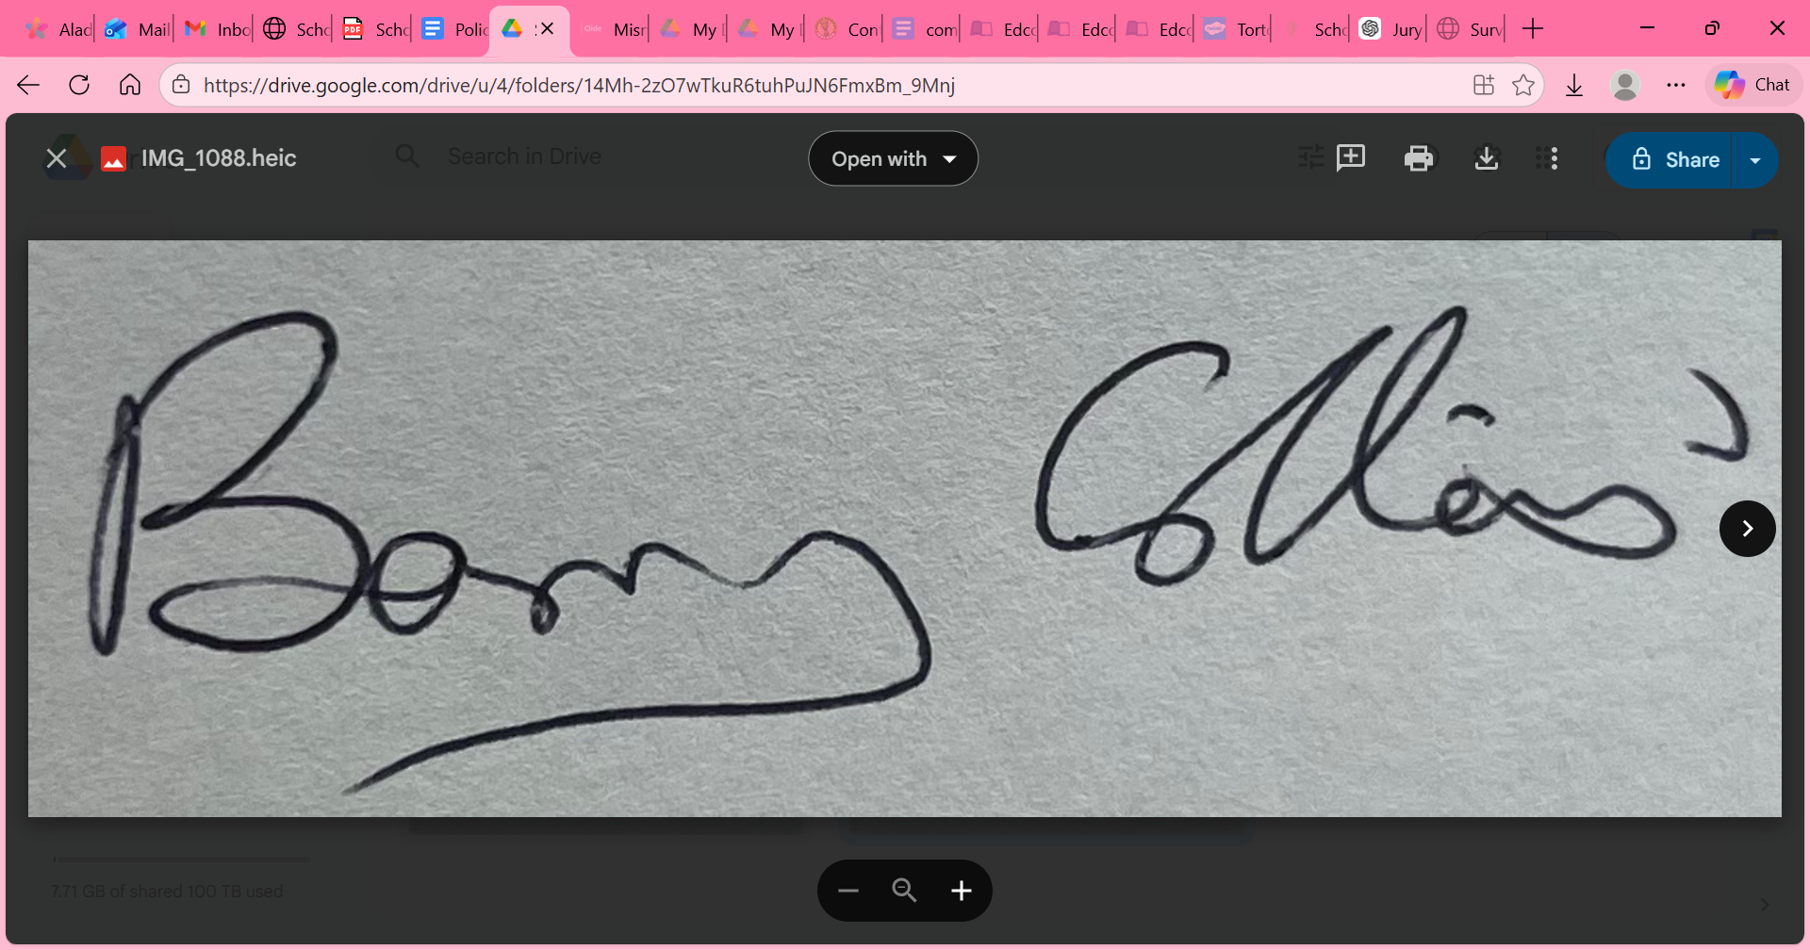 Date: 29-05-2025
Chairperson Board of Management
Signed: 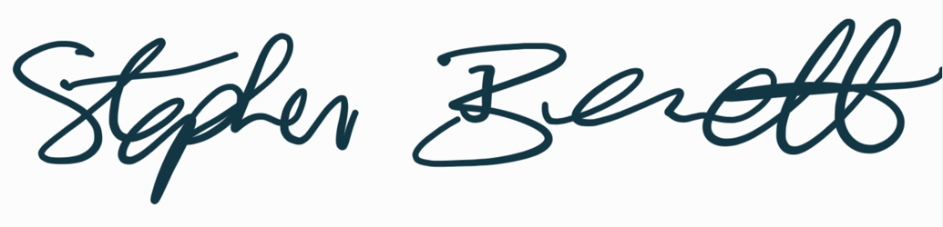 Date: 29-05-2025
School Principal

