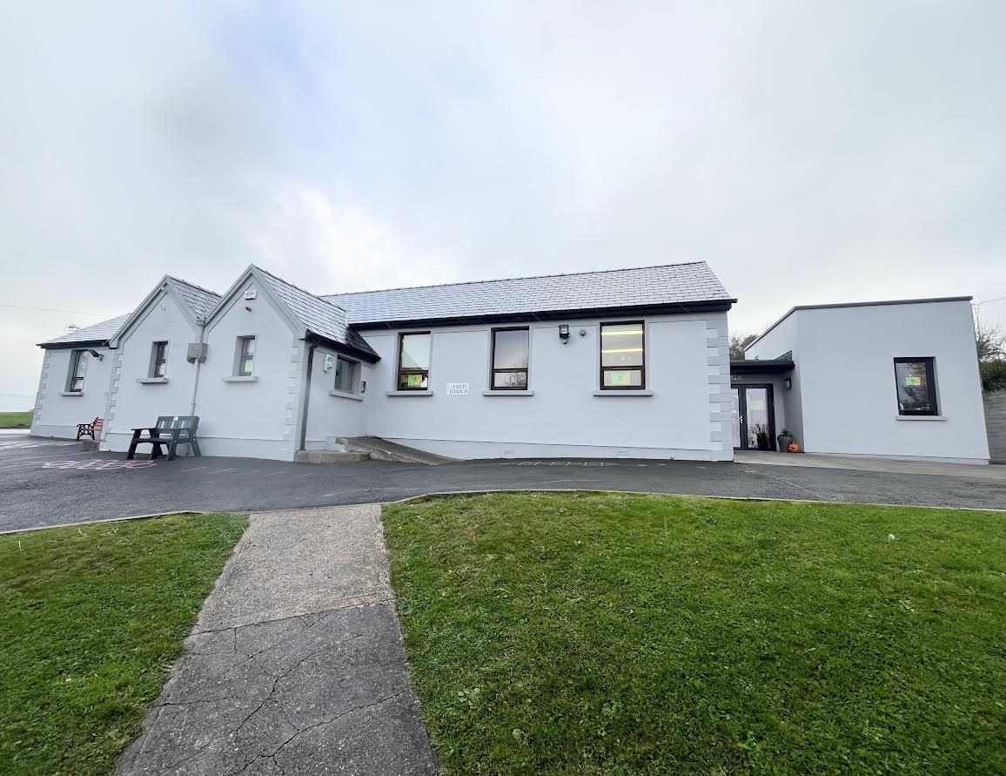 Kilmagner, Fermoy, Co. Cork P61V968
Phone: (025) 36802 Roll Number: 11337W Email: office@kilmagnerns.ie
Website: www.kilmagnerns.ie

Application Form for Admission 2026/2027

Please specify which class you wish to apply for: e.g. Junior Infants/Senior Infants/1st class etc. ______________________________
Places will be offered to applicants based SOLELY on the information given on this form. Applications for pupils applying to transfer from another school into classes other than Junior Infants may be subject to certain conditions as per the school’s Admission Policy.

If you have any questions about how to fill out this form, please contact the school for assistance. Please complete the form in BLOCK CAPITALS.

Name of Child: ____________________________________ Date of Birth: ____________
Home Address: __________________________________________________________________________
Eircode: __________________
Any information you give on this form will be treated with the strictest confidence and only used for the benefit of your child. Your application will not be accepted unless you have submitted your child’s Birth Certificate, PPS number and Baptismal certificate.
CLOSING DATE:
IF YOUR CHILD HAS ANY ASSESSMENTS RELATING TO HIS/HER DEVELOPMENT OR A SPECIAL NEED PLEASE MAKE AN APPOINTMENT TO DISCUSS SAME WITH THE PRINCIPAL OR A MEMBER OF STAFF AT THE EARLIEST POSSIBLE OPPORTUNITY AND NOT LATER THAN 24th OCTOBER 2024
USE BLOCK CAPITALS PLEASE
1. First name of child: ______________________ Surname of child:____________________ Male/Female : ____
2. Surname in Irish: (if known) _________________
3: Nationality: ________________________
4. Name and class of brothers/sisters already in the school (if applicable)_____________________________
__________________________________________________________________________
5. Number of children in the family: __________
6. Placing of child (1st, 2nd etc.): _________________________________________________
7. (a) PARENTS/GUARDIANS: The following information is needed for registration purposes.

Details of Parent/Guardian 1. | Details of Parent/Guardian 2
Name: | Name:
Occupation: | Occupation:
Nationality: | Nationality:
Mobile No: | Mobile No:
Work No: | Work No:
Email: | Email:
Language/s spoken at home: __________________
Please make us aware immediately if there are any custody issues/court cases pertaining to your child.

8. Home Address:
___________________________________________________________________________
Eircode: ________________
9. Home Phone No: __________________
10. Email Address 1: ________________________________________ (all school correspondence is via email)
Email Address 2: (optional)_________________________________
11. 1st contact person if parent/guardian not available:
Name:
_____________________________
Phone No. __________________________
Relationship to the child: ______________
2nd contact person if parent/guardian not available: Name: _____________________________
Phone No. __________________________
Relationship to the child: ______________
12. Date of Birth:_______________
13. Religion: _________________ Tick here if Baptised in Castlelyons Parish ______
PLEASE ATTACH COPY OF BAPTISMAL CERTIFICATE (if Baptised outside Castlelyons Parish) (original will be returned)
14. Ethnic/Cultural Background: _____________________________ (optional)
15. Child’s P.P.S. No.: ___________________________
16. Mothers Maiden Name: __________________
17. Name and address of pre-school or previous school attended:
_______________________________________
___________________________________________________________________________________________
18. Phone no. of previous school: _____________________________________________
I give permission to Kilmagner N.S. to discuss the needs of my son/daughter with the pre-school/school listed above.
19. Name and phone no. of Family Doctor: _________________________________________________________
20. Has your child any allergies/medical condition:
If yes please give details: ______________________________________________________________________
______________________________________________________________________
______________________________________________________________________
21. Does your child appear to have any difficulties with the following:
Hearing: Speech: Vision:
If you have answered yes to any/all of the above, please give details:
_________________________________________________________________________________________
PARENT/GUARDIAN CONSENTS
Please tick:
22. Do you give permission for your child to go on educational school trips/sports events under teacher supervision during the school day? e.g. incidental trips/walks to local historical buildings, woods etc. YES (___) No (___)
23. Sometimes journalists visit our school to take pictures of the children e.g awards/prizes, sporting events, first day at school etc. Do you give permission for your child to be photographed for school projects, local newspapers, and school related activities? YES (___) No (___)
24. Please indicate if you give permission for your child’s picture to be published anonymously on our school website and social media platforms. YES (___) No (___)
25. On occasion children are photographed/videoed during school activities, these are on display in the School Hall and in the classrooms. Also during the school year children may get the opportunity to visit educational exhibitions/venues where official photographers take photographs for newspapers. Please indicate if you give permission for your child’s picture to be published. YES (___) No (___)
The Board of Management cannot be held responsible for pictures/video taken by parents at matches, the Christmas Play, Celebrations, School Concert etc. In acceptance of this enrolment please accept that general photos may be taken in promotion of the school, please attach a letter if you do not wish your child to be included in such photos. We ask that you respect the privacy of others, please do not post videos, group photos etc on Social Media platforms. YES (___) No (___)
26. Sometimes the school is requested to pass on names of children and their addresses to the H.S.E for the protection of your child’s health and welfare e.g Dental Clinic, immunisation etc. Do you allow the school to pass on this information to H.S.E. YES (___) No (___)
27. I give permission for my child to be withdrawn as part of a group for group teaching. (Where a group from within the class are withdrawn for teaching in a certain subject area for a set period of time or according to a certain rota, this is very important particularly in multiple class situations) YES (___) No (___)
28. I give permission for my child to receive learning support/resource teaching as deemed appropriate. YES (___) No (___)
29. Standardised Testing is done with all pupils from Infants to 6th class. Your child may also participate in individualised Diagnostic testing to better assist their educational achievement. Please indicate if you give permission for your child to partake in these tests. YES (___) No (___)
30. Secondary schools, when children are transferring to second level, sporting bodies and when children are taking part in games outside school, request details regarding contact information and date of birth. Please indicate if you give permission for your child’s details to be given to these bodies. YES (___) No (___)
31. The school teaches Relationship and Sexuality Education (RSE) using guidelines provided by the Department of Education and Skills. Do you give permission for your child to participate in this programme? YES (___) No (___)
32. The Stay Safe Programme is part of our School Curriculum. Do you give permission for your child to participate in this programme? YES (___) No (___)
33. Our school policies are available to read on our website www.kilmagnerns.ie . By signing this form you are indicating that you have read our Enrolment Policy & Code of Behaviour. YES (___) No (___)
The information I have given in this form is accurate.
Signature of Parent/Guardian 1: ___________________________________
Signature of Parent/Guardian 2: ___________________________________
IF ANY OF THE DETAILS IN THIS FORM CHANGE - FOR EXAMPLE, IF YOU MOVE HOUSE, CHANGE YOUR PHONE NUMBER ETC. PLEASE INFORM THE SCHOOL IMMEDIATELY.

